Game Name : Japanese typing game  
  
**The game genre :**

Japanese typing game is a game to practice recognizing Japanese characters.

The game is divided into four difficulty levels. As the difficulty increases, Japanese characters such as "katakana" and "voiced sound" will be gradually added.

This is a time-based game. The timeline will gradually shorten and change colors. After the timeline disappears, the game ends.

Before the letter falls to the bottom of the screen, the player can successfully enter the Romanization of the letter to earn points and extend the timeline. When the letters fall, the timeline will consume faster. As the player's score increases, the speed at which the letters fall will increase, increasing excitement.

**How to recognize whether the player's input corresponds to the Romanization of Japanese :**

We need to set a string of each Japanese character to store Romanization.

After that use the “foreach” to read the player's input, then set the index as a pointer, and determine the current character according to the index variable.   
  
Take [SA] as an example, when the index is 0, the character will be set to [S].  
When the recognized player input matches the character of index, let index+1 and the character becomes [A].   
If the player successfully enters [S][A], they will be able to score successfully. However, if the player makes a mistake midway, the index will be resetting and the player needs to enter again. **The User Interface :**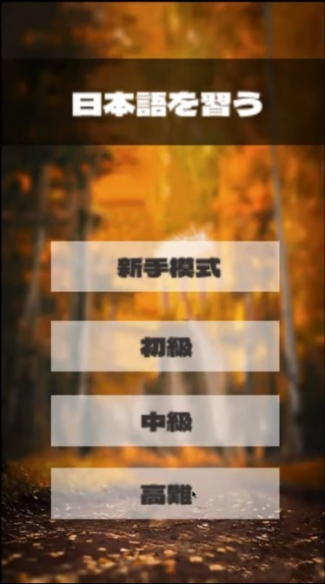  
Choose the difficulty of the game in StartScene.  
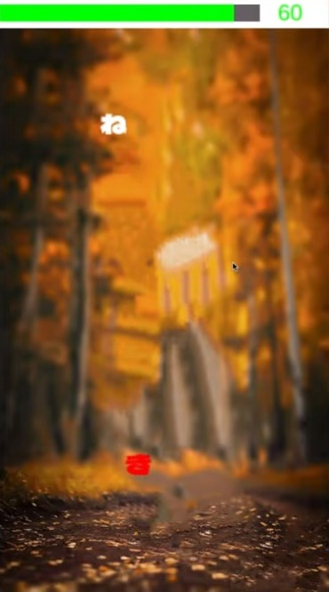

The green bar mean timeline. When the item fall to the certain distance, the color will change into red, notify the player that the item will fall to the bottom.

  
When the timeline reach a certain value, the color will hue as yellow, notify the player time's running out.  
  
  
When the timeline reach a certain value, the color will hue as red, notify the player that no more times.  
  
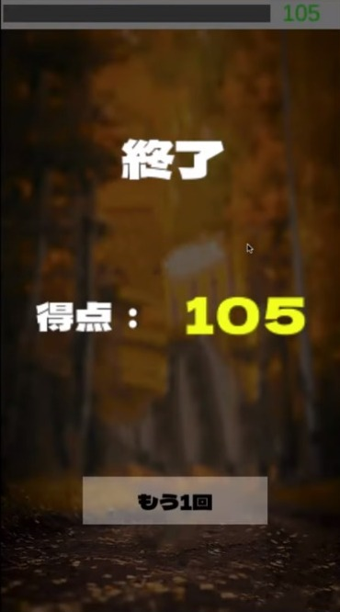  
 When EndGame will open the EndGame windows to show the total score.